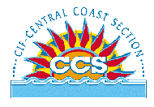 | CENTRAL COAST SECTION  CROSS COUNTRY  Organizational Meeting  August 13, 2014 | 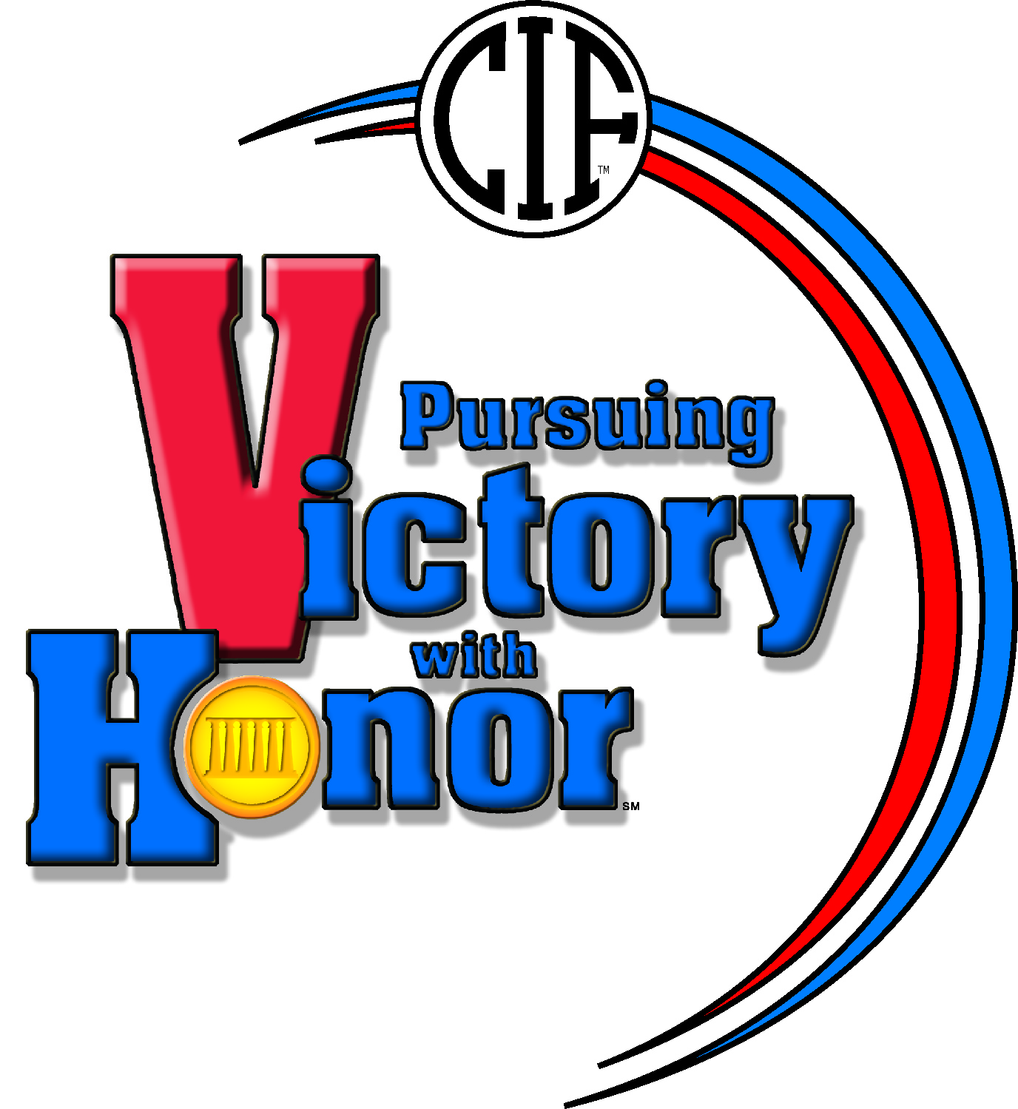
- Welcome & Introductions
- Approval of Agenda
- Additions to Agenda
- Approval of Agenda

- Review of Tournament Guide Dates
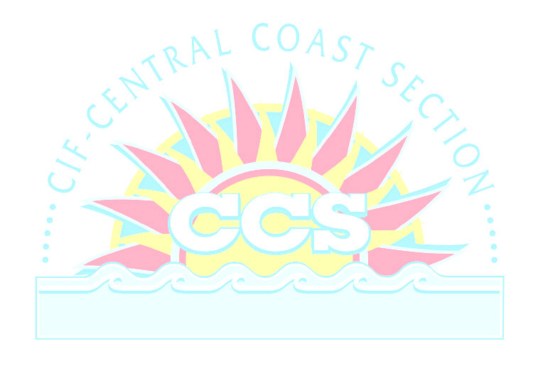
A. Meet: Saturday. November 15, 2014 (rain out date Tues. Nov.18th)
- State Meet Date: November 29, 2014, Woodward Park, Fresno
- Evaluation Meeting: Tuesday, December 2, 2014, 7:00pm (if necessary)

- CCS Meet
- Review By-laws

- Site: Toro Park
Meet Director: Steve Filios - coordinator
Timing & Results: Record Timing

- CBEDS

- CCS At-large times

- Participating School Sheet – check for accuracy

- 2014 Schedule of Meets
1. Approved CCS Invitationals
2. Crystal Springs Schedule/Handbook
3. League Meets-review

- CCS Meet time schedule
Division I | Boys: | 10:00 AM | Girls | 10:35 AM
Division II | Boys: | 11:10 AM | Girls | 11:45 AM
Division III | Boys: | 12:20 PM | Girls | 12:55 PM
Division IV | Boys: | 1:30 PM | Girls | 2:05 PM
Division V | Boys: | 2:40 PM | Girls | 3:15 PM

- Review rain-out procedures. Reps make sure your contact phone
numbers are listed on today’s sign in sheet. These are the numbers
used when notifying reps of a rain out. Note: farthest reps are called first

- Review Toro Park Guidelines: Please inform all coaches
  - Parking procedures/admission
  - Restrooms
  - Image of HS X/C with Monterey County Parks
  - Trash

- Admission
- Please remind runners, parents, and other interested folks that there is an entrance charge for the CCS Cross Country Meet.
- Admission for Coaches/Athletes
3. No supervision pass gate list

- Other Items
1. Warm-up & warm-down – no runners on course after start of race/suggested warm-up areas
2. Award Procedures – after each division
3. T-shirt availability- 5 days ahead
4. Results posting-live and post meet
5. Certificates of Participation
6. Other items of concern
A. N
- CIF State meet
  - Entry numbers for 2014-note change

- NFHS rule change for Track & Field

- New CIF Practice Rules

- Honor coach

- Items added to agenda

- Adjournment

