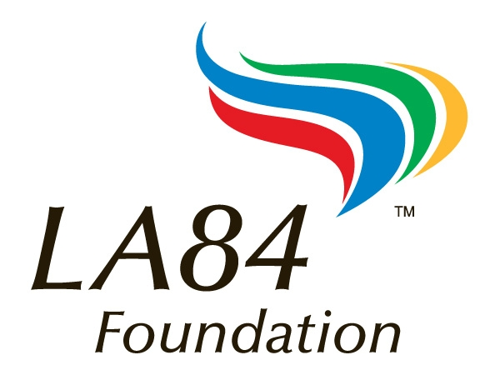
LA84 Foundation
June 18, 2011, Mt. SAC Cross Country Clinic Agenda
There will be two series offered at today’s clinic featuring one presentation from each series being offered at every session during the day.
Track 1: Beginning Series. This series is designed for the beginning or inexperienced coach. It is recommended for coaches with five years or less of experience. Topics include the basic physiology of training a high school distance runner, how to construct a season long training plan, how to recruit and build your team, and all the things you need to know as a head coach to stay one step ahead of the CIF, your AD, and the principal.
Track 2: Advanced Series: This series is designed for the experienced coach who understands the basic physiology of training distance runners and who already has organizational and recruiting skills. Speakers will be presenting sessions that are specific and assume a common level of knowledge and a common vocabulary specific to the sport.

Time Session Topic Location
8:00 - 8:40 Registration and Lunch Sign-ups Building 9C

8:40 - 9:00 Opening Welcome and Clinic Directions 9C - East

9:00 - 10:00 Beginning Series
101 Great Tips To Recruit Runners & Build Your Program Into a Powerhouse Tim O’Rourke 9C West
Advanced Series
Developing Average Runners Into A Team That Can Compete at the Highest Level Tim McIntosh 9C East

10:15 - 11:15 Beginning Series
Basic Physiology and Training Principles for Coaching a
Successful High School Cross Country Team Ken Reeves & Bill Tokar 9C West

Advanced Series
Creating a Culture of Teamwork and Competitiveness for High School Girls. Renee Smith 9C East
or
Strength / Proprioceptive Training For Cross Country Runners" - Strength Training And
Plyometric Exercises To Reduce The Occurrence Of Medial Tibial Stress Syndrome
(Shin Spints), And Chronic Ankle Instability, And Other Lower Extremity Conditions
Associated With Cross Country Bill Ito 9C Conference Room

11:30 - 12:30 Beginning Series
The Things You Must Know/Do/Follow To Keep Your Principal and AD and the CIF Happy Tim O’Rourke 9C West

Advanced Series
Basic Principles of Cross Country Training-Part 1 Marco Ochoa 9C East
Or
Movement Assessments For Coaches" - A Hands On - Basic Approach To Assessing And
Identifying Movement Dysfunction That May Lead To Chronic Lower Extremity Conditions Bill Ito 9C Conference Room

12:30 - 1:30 Lunch: Clinicians will be available throughout the lunch hour in the area outside 9C for informal discussions.
Afternoon Agenda on Back!

Afternoon Agenda

1:30 - 2:30 Beginning Series
Summer to November: The Basics of Building a Successful
Season Long Training Program Ken Reeves & Bill Tokar 9C West

Advanced Series
The Training Plan That Lead St. John Bosco to the 2010 California State XC Championship Tim McIntosh 9C Carpet
Or
What Every Coach--Assistant and Head Coach--Should Be Prepared to Handle
At Every On Campus Practice, Off-Campus Practice and Meet Bill Ito 9C Conference Room

2:45 - 3:45 Beginning Series
The Difference Between Good and Great. All of the Little Things That Will Take Your
Program To the Next Level - Hands on Development of Training Program Ken Reeves & Bill Tokar 9C Conference Room
Advanced Series
Developing Female High School Runners To Maximize Long Term Success Renee Smith 9C East
Or
Basic Principles of Cross Country Training-Part 2 Marco Ochoa 9C West

3:45 Turn in Your Completed Evaluations and Receive Your Certificate of Completion and Your Free LA84 Foundation Cross Country Coaching CD!

