Magdalena Lewy Boulet was born in Jastrzebie, Poland on August 1, 1973. Magdalena, along with her mother and brother, followed her father to Kiel, Germany in 1988 and then three years later to Long Beach, California. Magdalena had been a swimmer before her family arrived in Long Beach, but when she saw the swimmers there, she realized that they were far above her. She finished out the season on the swim team, but when it finished Magdalena joined track to see if she could excel here. Magdalena did very well and thinks that starting her running career later was advantageous for her because she’s had less time to become injured.
After she graduated, she spent two years at a community college before she transferred to UC Berkeley. The coach at UC Berkeley, Tony Sandoval, believes that Magdalena was a great runner who was always willing to work. Magdalena majored in human biodynamics and used her knowledge to help her out on the track. During her two years at Berkeley, Magdalena became an All-American for long distance. She also came to love Berkeley because of the campus, the weather, the many places for her to train, and it’s where she met her husband, Richie Boulet. (He was also a distance runner and once ran a 3:53 mile.)
After her stint at Berkeley, Magdalena finished her graduate’s degree in exercise physiology at CSU East Bay, helped coach at Berkeley, and married Richie Boulet. As her husband ran marathons, Magdalena decided that she could share his interest and become a marathoner as well. Thus, the birth of a great marathon runner came about.
Magdalena had one more thing she wanted. Magdalena wanted to become a US citizen. Normally, becoming a citizen involves many forms, tests, and time. But, Magdalena became a US citizen on a very important day. Magdalena became a US Citizen on September 11, 2001. When she and her husband (they had no idea what was going on) arrived at the citizenship office in San Francisco, people were very upset, worried, and sped everything along. A ceremony that should have taken four hours, took only five minutes. As Magdalena and Richie drove back home, they listened to the events on the radio. Magdalena says that she feels like she gained many opportunities on a day that many lost theirs.
As the years passed, Magdalena’s marathon career picked up. In 2002, she came in first at the Pittsburgh Marathon with a 2:36:48. The next year, she came in second at the Pittsburgh Marathon with a 2:31:38. In 2004, Magdalena came in fifth at the Olympic trials with a 2:30:50. Magdalena was heartbroken after she couldn’t go on to the Olympics, but she didn’t give up. In 2005, she gave birth to her son Owen. By the New York Marathon in 2006, Magdalena was up and running again. She ran a 2:42:38 and placed fifteenth. She also placed first in the Orange County marathon with a 2:50:41. She had a very busy year in 2008. She came in 6th for the 10,000 m at the Olympic Trials and 3rd at Stanford. She also placed 11th at the NYC Marathon. She qualified for the 2008 Olympics with her 2:30:19, but sadly she did not finish the marathon in Beijing.
Although she didn’t finish the marathon in Beijing, Magdalena has no plans on giving up. She wishes to continue coaching at Berkeley and to stay in top physical shape. She also wishes to help others achieve their athletic dreams.
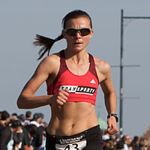 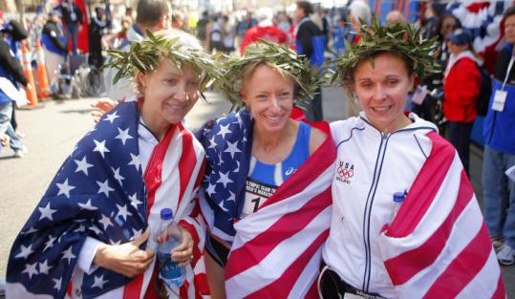
After the Olympic Trials. Blake Russell (3rd), Deena Kastor (1st), Magdalena Lewy Boulet (2nd)

