Saratoga and Lynbrook High School XC Presents  8th Annual Marshall Clark 4 Mile Run  Road Race - XC Kick Off |  | 
Date: Saturday, August 28th, 2010  Registration on line only at http:// www. active.com  Register early, race limited to 350 runners (same day registration available if race limit not met; Saratoga and Lynbrook Alumni not subject to race limit restrictions)  Race day registration opens 7:00, Race at 8:00  Cost: $28 through Aug 25th, $35 after (w/T-Shirt) (Registration $15 each for a family of 4 or more, race day only)  Race day registration  Make payable to: Saratoga XC  Place: Saratoga HS Track (20300 Herriman & Saratoga-Sunnvale Rd)  Awards: 3 deep in eight age groups (M & F)  12 & under, 13-15, 16-18, 19-29, 30-39, 40-49, 50-59, 60+  Info: www.LYNBROOKSPORTS.com (408) 353-4329 | 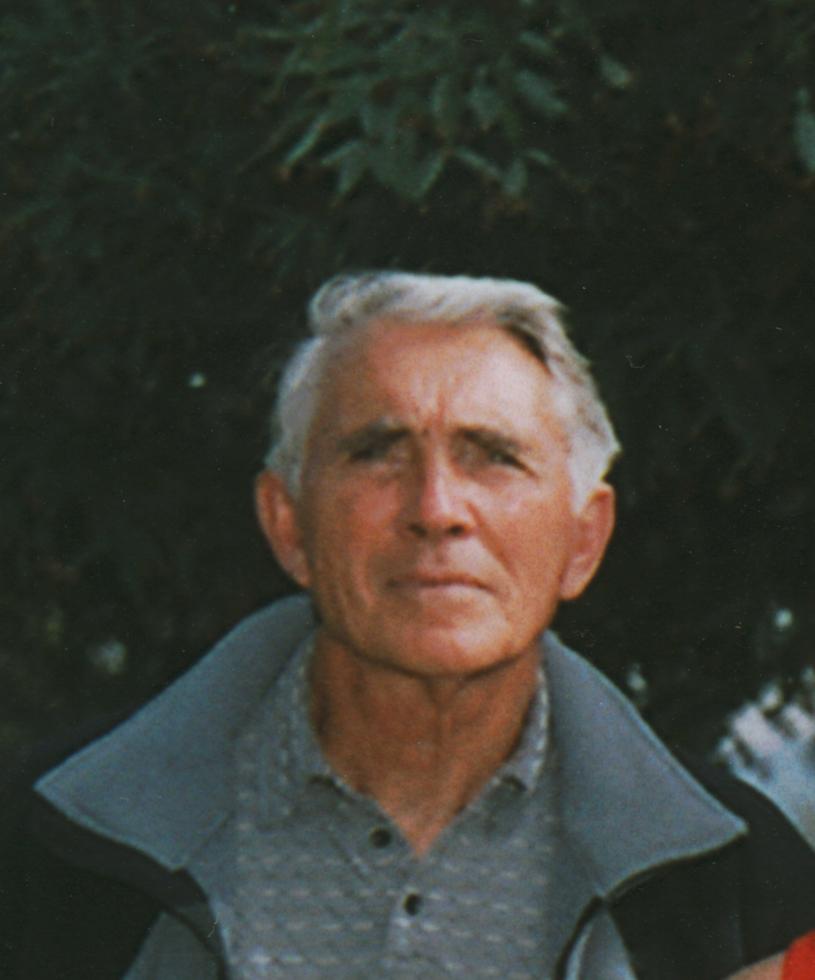  Course Map–Course Description

Course Records:  BENTON. DUSTIN 26:29.8 00-12 6:37 ’07  WOLFSMITH. LANCE 21:10.9 13-15 5:17 ‘07  IYER. HARI 20:40.9 16-18 5:10 ‘06  IYER. HARI 20:30.7 19-29 5:07 ‘07  SEALY. KENRICK 20:54.3 30-39 5:12 ‘06  SHAVER. JEFF 21:35.0 40-49 5:23 ‘04  BORDONI. JIM 25:01.5 50-59 6:15 ‘07  ROSTEGE. TIM 31:00.5 60+ 7:45 ‘09  SPEEDY. AMANDA 29:47.0 00-12 7:26 ’04  PASCALE. HAYLEY 24:04.4 13-15 6:01 ‘06  BERGMAN. JENNIFER 23:47.8 16-18 5:57 ‘08  FOLLMAR. ALICIA 23:08.8 19-29 5:47 ‘08  PARK. CHRISTINA 23:51.5 30-39 5:58 ‘06  NAST. LIZ 27:21.0 40-49 6:50 ‘03  FOLLMAR. DEBBIE 28:16.8 50-59 7:04 ‘06  PARSONS. MARCIA 39:47.0 60+ 9:57 ‘08 | Last Years Top 3:  LIAO. KEVIN 21:15.8 M 1 16-18  SIGNORE. LUCA 21:23.8 M 2 16-18  IYER. HARI 21:51.8 M 3 19-29  WAI. KAREN 27:06.9 F 1 16-18  ELLENBURG. COURTNEY 27:38.2 F 2 13-15  WOLFSMITH. JULIE 27:54.4 F 3 40-49  Previous Winners:  2009 – LIAO. KEVIN 21:15.8 M  WAI. KAREN 27:06.9 F  2008 – WOLFSMITH. LANCE 21:10.0 M  FOLLMAR. ALICIA 23:08.8 F  2007 – IYER. HARI 20:30.7 M  FOLLMAR. ALICIA 23:31.4 F  2006 – SILLER. HARREL JR 20:37.1 M  FOLLMAR. ALICIA 23:12.5 F  2005 – IYER. HARI 21:41.0 M  FOLLMAR. ALICIA 24:08.0 F

First |  |  |  |  |  |  |  |  |  |  |  |  |  |  |  |  | Last

Street |  |  |  |  |  |  |  |  |  |  |  |  |  |  |  |  |  |  |  |  |  |  |  |  |  | City

 |  |  |  |  |  |  |  |  |  |  |  |  |  |  |  |  |  | - |  |  |  |  |  |  | M | / | F
St |  |  |  | Zip |  |  |  |  |  |  | Phone |  |  |  |  |  |  |  |  |  |  |  |  |  |  |  |  |  |  |  | Age |  |  | Shirt Size (S,M,L,X)
Email (for results and a reminder for next years race)
 |  |  |  |  |  |  |  |  |  |  |  |  |  |  |  |  |  |  |  |  |  |  |  |  |  |  |  |  |  |  |  |  |  |  |  | Team / School
_______________________________________________ |  |  |  |  |  |  |  |  |  |  |  |  |  |  |  |  |  |  |  | ___/___/___ |  |  |  |  | ________________________________________________
Signature of Athlete |  |  |  |  |  |  |  |  |  |  |  |  |  |  |  |  |  |  |  | Date |  |  |  |  | Signature of Parent (if under 18)

WAIVER: I waive for myself, my heirs and assign all rights and claims for damages against anyone associated with the race: Saratoga HS, and its officers, officials, boards, commissions, employees and volunteers. Saratoga/Los Gatos School District, promoters, sponsors, officials and the Saratoga XC Team. I also certify that I am physically fit and can participate in this event at my own risk.

